**Description:** This documentation contains the specifications of the ERP Report web application.

1. **Log-in**

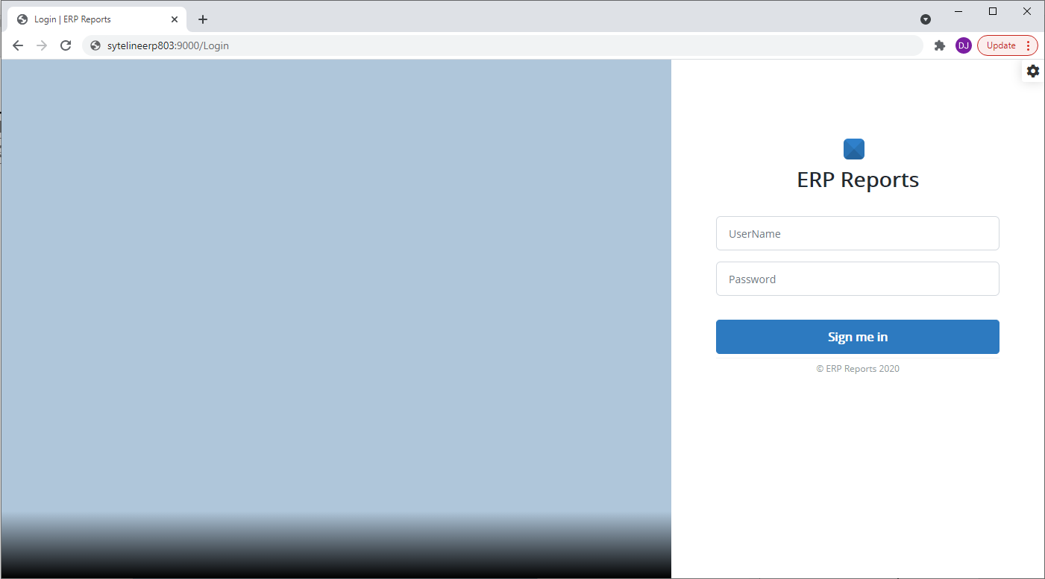

**2**

**1**

1. URL to access the “ERP Reports” web application ( <http://sytelineerp803:9000> )
2. Enter “Username” and “Password”. Note: This is different from the username and password from ERP System. But can be set as same during creation of user
3. **Main Page and Menus**

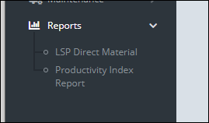 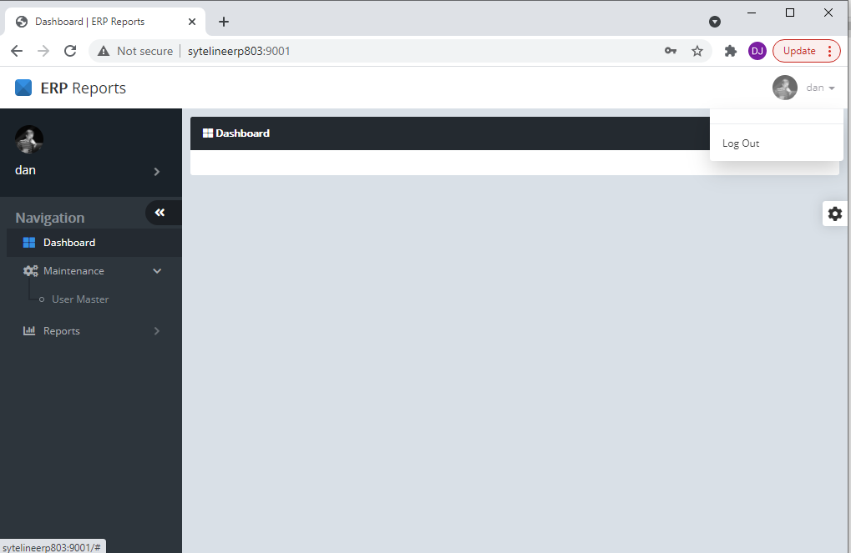

**3**

**2**

**1**

1. Logout – to logout from the system
2. Maintenance menu – contains user master management page
3. Reports menu – contains LSP Direct Material and Productivity Index report pages
4. **Maintenance – User Master (Contains the list of all users with access in ERP Report system)**

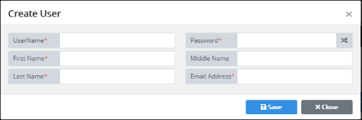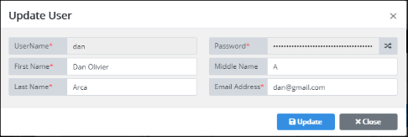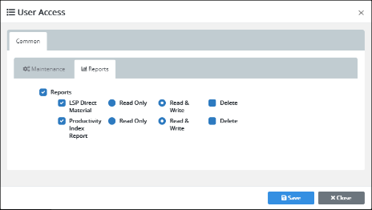

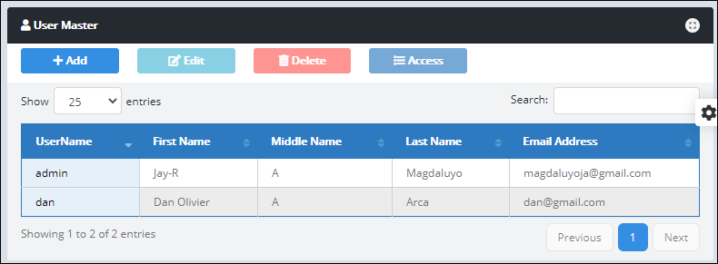

**4**

**3**

**2**

**1**

**5**

1. **Add –** use to add new user in ERP Report
2. **Edit –** use to update details of the user in ERP Report
3. **Delete –** use to remove or delete access of the user in ERP Report
4. **Access –** use to manage the user’s page access. Grant or revoke access in each page in ERP Report
5. List of all registered user in ERP Report web-based application
6. **Reports – LSP Direct Material (Page to generate all types of Direct Material Reports)**

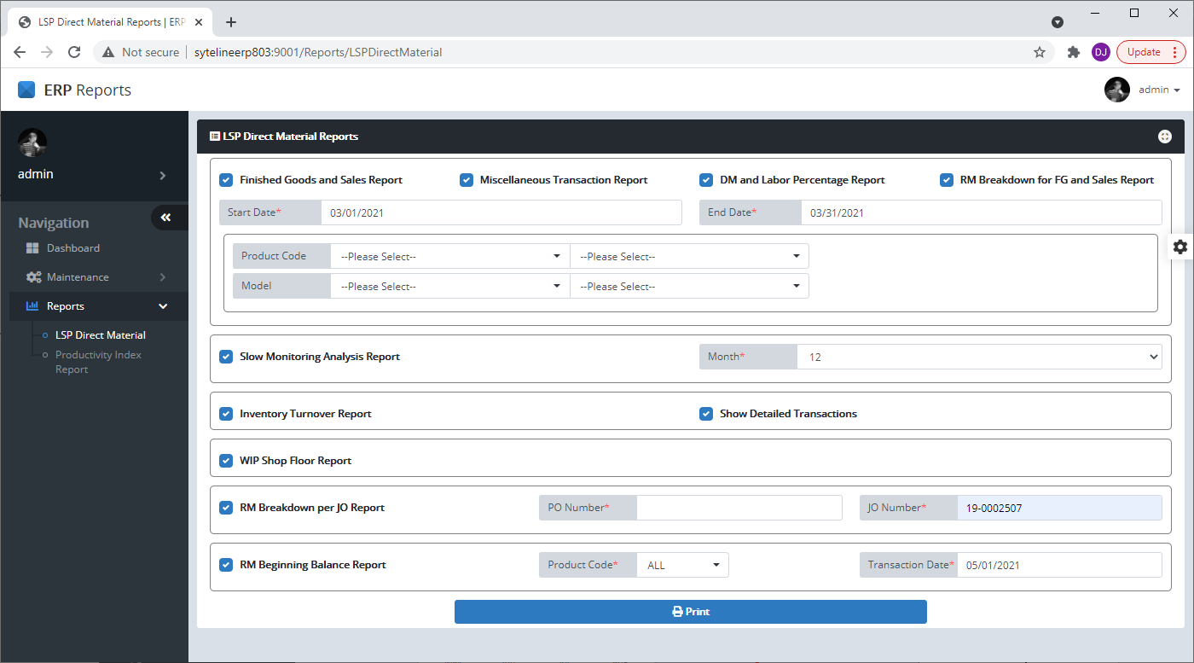

1. **Finished Goods Sales Report –** check or uncheck to include/exclude the Finished Goods and Sales report in generation of Direct Material Reports. Required input parameters = Start Date and End Date.
2. **Miscellaneous Transaction Report –** check or uncheck to include/exclude the miscellaneous transaction report in generation of Direct Material Reports. Required input parameters = Start Date and End Date.
3. **DM and Labor Percentage Report –** check or uncheck to include/exclude the direct material and labor percentage report in generation of Direct Material Reports. Required input parameters = Start Date and End Date. Optional parameters: Product Code (Start and End) and Product Model (Start and End)
4. **RM Breakdown for FG and Sales Report –** check or uncheck to include/exclude the RM breakdown of FG and sales report in generation of Direct Material Reports. Required input parameters = Start Date and End Date.
5. **Slow Moving Analysis Report –** check or uncheck to include/exclude the slow-moving analysis report in generation of Direct Material Reports. Required parameter = Month (12 or 24 months)
6. **Inventory Turnover Report –** check or uncheck to include/exclude the inventory turnover report in generation of Direct Material Reports. Option parameter = show detailed transactions or not (check/uncheck option)
7. **WIP Shop Floor Report –** check or uncheck to include/exclude the WIP shop floor report in generation of Direct Material Reports.
8. **RM Breakdown per JO Report –** check or uncheck to include/exclude the RM breakdown of specific JO report in generation of Direct Material Reports. Required parameter: PO Number and/or JO Number.
9. **RM Beginning Balance Report –** check or uncheck to include/exclude the RM beginning balance report in generation of Direct Material Reports. Required parameters: Product Code (“ALL” or specific product code) and transaction date.
10. **Reports – Productivity Index Report**

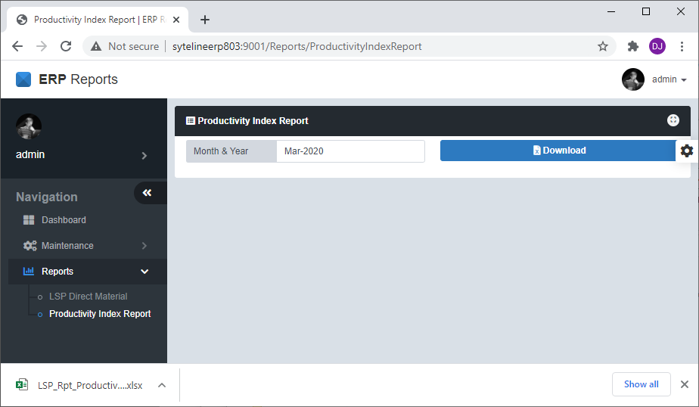

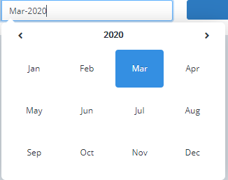

**3**

**2**

**1**

1. Select the month and year to generate the productivity index report
2. Click download button to download the report
3. The generated productivity index report will show in the download files in google chrome

**ADDITIONAL NOTES**

1. Recommended browser to use is “Google Chrome”
2. At first, the browser will not allow multiple downloads per site, it should be set one time. Site Setting -> “Pop-ups and Redirects” = Allow; “Automatic Downloads” = Allow

